

* **TITLE OF THE PROJECT**“DATA AND VOICE COMMUNICATION via LI-FI”
* **CATEGORY**

Communication Project

* **EASY HIGHLIGHTS**

1. Uses light as a medium for communication
2. Easy Control
3. Cheap
4. A Developing Technology
5. Self-Explanatory Kit Available
6. Self-Explanatory Kit Available
7. Project file available
8. Data Sheets also available

* **HARDWARE USED**

**Transmitter Side**

* Power Supply (9V Battery)
* Battery Connectors
* Capacitors
* Resistors
* Crystal Oscillator (3.58 MHz)
* Voltage Regulator (7805)
* Op-Amp(IC 741)
* Semiconductor Diodes
* Transistors
* Push buttons
* Zener diode
* Variable resistance
* Laser Diode
* Condenser Microphone
* Encoder IC (UM91215b)
* Connecting Clamps and Screws

Value of Resistors: -

R1 150

R2 27K

R3, R4, R6 10K

R5 1K

R7 470

VR1 10K

Value of Capacitors*: -*

C1 100F 2.5V

C2 .04

C3 1000F

**Receiver Side**

* Power Supply (9V Battery)
* Battery Connectors
* Photo diode
* Op-Amp(IC 741)
* Capacitors
* Crystal Oscillator (3.58 MHz)
* Voltage Regulator (7805)
* Resistors
* Variable resistance
* Diodes
* Transistors
* Speaker
* Decoder IC (CM8870)
* BCD to 7 Segment Decoder (IC 7447)
* Soldering wire and Iron
* Common Anode 7 Segment Display
* Connecting Clamps and Screws

Value of Resistors: -

R1-R5 10K

R6, R7 100k

R8 330K

R9-R16 470

VR1 10K

Value of Capacitors: -

C1 .04

C2 1000F

C3 470F

C4 47F

C5, C6 .1F

**ABSTRACT + DESCRIPTION**

A simple prototype of an optical wireless data and voice system by using Semiconductor Laser as a source for the transmitter has been proposed. In this project, we designed and implement a wireless optical transmitter and receiver system that established data and voice communication at some distances with weak signal via visible light communication. In addition, this project also proposed visible light communication at certain angle which is a new solution or techniques to undertaken the characteristic of light that propagates in a straight line although the signal is very low or weak over long distance. The wavelength that used for this project is 635nm which is visible wavelength range. Based on the experimental results, the visible light communication system can work successfully within in distance up to 10 meters and sensitivity angle of the photodiode at receiver that view the visible light coming from the transmitter is up to 140˚. This project is successfully improved the transmission distance and signal coverage area effectively with low cost of hardware, high communication speed and almost no limit to bandwidth.

* **WORKING PRINCIPLE (100-200 words)**

Optical transmitters are typically composed of a buffer, driver, and optical source. Often, optical connectors are also integrated into the final package. The buffer electronics provide both an electrical connection and “isolation” between the driver electronics and the electrical system supplying the data. The driver electronics provide electrical power to the optical source in a fashion that duplicates the pattern of data being fed to the transmitter. Finally, the optical source (LD in this kit) converts the electrical power to light energy with the same pattern

Once light energy from optical source of transmitter reaches the destination (receiver) it must be converted back to a form of electrical energy with the same information pattern that was fed to the transmitter by the person sending the message. Analog optical receivers typically perform these functions using three elements: a photo detector, an amplifier and sometimes a buffer. The photo detector converts light energy (optical power) to an electrical current. Any pattern or modulation imparted in the optical power (from, for instance, an optical transmitter) will be reproduced as an electric current with the same pattern. Passing of signal through air can cause distribution losses can reduce the optical power, resulting in a comparatively weak electrical signal from the photo detector. To compensate of the electrical signal. Finally, buffer electronics isolate the photo detector and amplifier from any load the receiver is required to drive.

**APPLICATIONS –**

1. TRAFFIC LIGHTS

Traffic lights can communicate to the car and with each other. Cars have LED-based headlights, LED-based cake lights, and cars can communicate with each other and prevent accidents in by exchanging information

2-INTRINSICALLY SAFE ENVIRONMENT

Visible Light is safer than RF, hence it can be used in places where RF can't be used such as petrochemical plants

3- Airlines

Whenever we travel through airways we face the problem in communication media, because the whole airways communication are performed on the basis of radio waves. To overcome this drawback on radio waves, li-fi is introduced.

4- ON OCEAN BEDS

Li-Fi can even wok underwater where Wi-Fi fails completely, thereby throwing open endless opportunities for military/navigation operations.

5- Other Applications

Street lamps (as free access points)

Hospitals (in few medical instruments)

**REFRENCES**

* <https://spectrum.ieee.org/telecom/internet/lifi-gets-ready-to-comete-with-wifiwww.atmel.com>
* [**https://en.wikipedia.org/wiki/Li-Fi**](https://en.wikipedia.org/wiki/Li-Fi)
* **http://purelifi.com/**
* <https://www.lificonsortium.org/technologywww.webopedia.com>
* <https://whatis.techtarget.com/definition/LiFi>
* <https://purelifi.com/brave-new-world-light-fidelity-led-data-transmission>
* <https://www.erewise.com/current-affairs/li-fi-technology-light-fidelity>
* [**www.ijies.org/attachments/File/v2i3/C0397022314.pdf**](http://www.ijies.org/attachments/File/v2i3/C0397022314.pdf)
* [**https://learn.sparkfun.com/tutorials/integrated-circuits**](https://learn.sparkfun.com/tutorials/integrated-circuits)
* **BLOCK DIAGRAM**

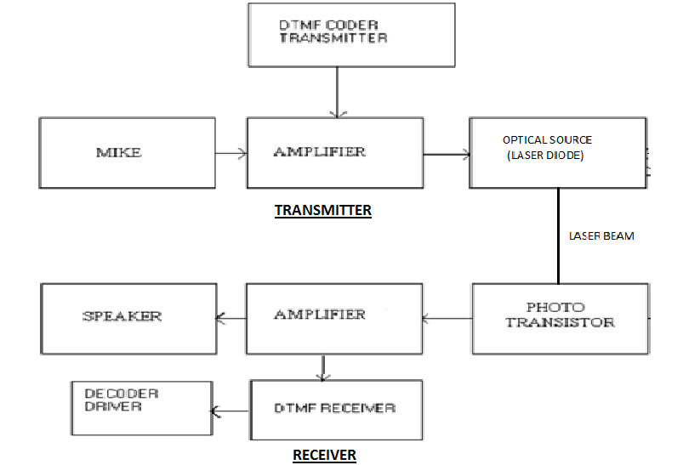

* **PROJECT IMAGE (ABSTRACT)**